**Java Assessment**

Develop a small web application to generate random strings based on the inputs given by the user. Write a RESTful API to pass on user input to the application server and return the generated strings. Save the generated strings in the database and provide an option to the user to view the previously generated strings. Use the database of your choice.

The input web form will allow users to generate random text strings and display the results on a separate web page.

**Input Form:**

Number of strings 

Number of characters in each string 

Which characters are allowed to occur in the strings?

 Numeric digits (0-9)

 Uppercase letters (A-Z)

 Lowercase letters (a-z)

Do you want each string to be unique?

Each string should be unique

Identical strings are allowed

 

**Output Page:**

Below are the generated strings

GRt5OA5NPzI6v4PeiMvA

zflIcJPmivoSQCkMba6D

syVoreeXVH0osioKGnM3

EE9NwBorP9Wwn15unmYs

o6VTstt1tUUhXsYzjVYH

 

**Sample Input Form:**

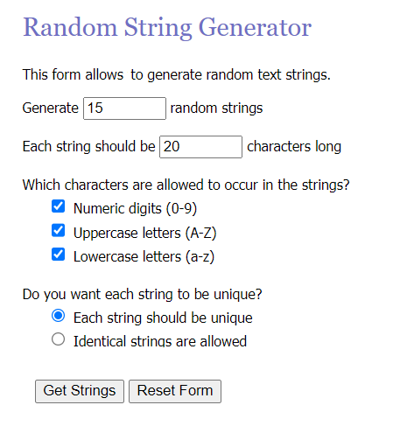

**Sample Output Page:**

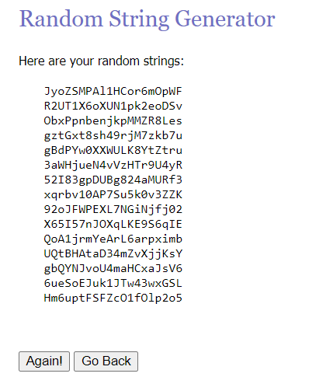

**Code Submission:**

1. Create a public git repository
2. Push your code in that repository
3. Share link of repository

**Plus:**

It will be a plus if you host the application on your server